Technical writing

Mapping commands Help pages

Problem
Pressing F1 in menus sometimes bring to a bad or incomplete Help page. Also the pages don’t describe the “To access this command” correctly.
Most of the “To access this command” only lists the menu bar commands, sometimes wrong. The Notebook bar and other ways to access the command are not listed. For example
- From the menu
- From the context menu
- From the Tabbed User Interface
- Icon associated
- From the Side bar
- From the status bar
- From the sheet bar.

Objective
The aim is to list the help pages and describe the User Interface access to access the command.
An image worth 100’words:
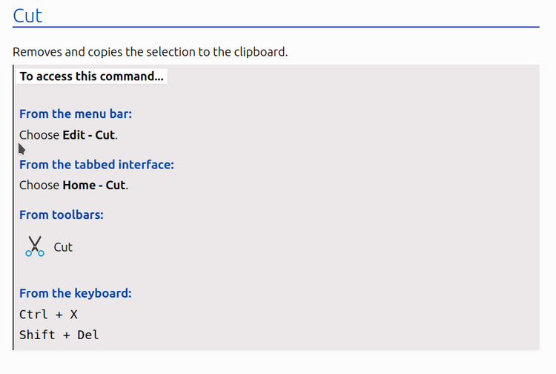

Setup
- Install LibreOffice latest release (7.6.x) and the Help
- Enable Tabbed UI : View – User Interface – Tabbed.
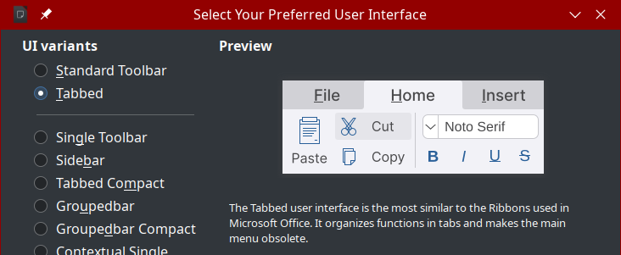
- Open a document for the application
- For each menu bar entry
  - Highlight the command in menu entry, for example Edit - Cut
  - Press F1
  - Check is the page contains a description similar to the image above
  - Verify consistency
- Write down in a simple document
  - The menu path (e.g. Edit - Cut)
  - The URL of the help page (e.g. file:///opt/libreoffice7.6/help/en-US/text/shared/guide/startcenter.html?System=UNIX&DbPAR=WRITER&HID=sfx/ui/startcenter/StartCenter#bm_id0820200802550237
  - How to get section (see image above)
    - From the menu
    - From the context menu
    - From the Tabbed User Interface
    - Icon associated
    - From the Side bar
    - From the status bar
    - From the sheet bar.
Send the document to me

Draw
https://bugs.documentfoundation.org/show_bug.cgi?id=155877

Impress
https://bugs.documentfoundation.org/show_bug.cgi?id=155878

Notes
When pressing F1, it is possible to reach an error page. Please take note of the HELP_ID

